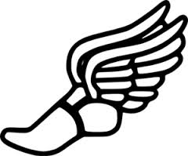
Waterloo High School
Girls Track and Field Records

Event | Performance | Name | Year
High Jump | 5'4" | Susan Hick/Genna Bourgeois(i) | 81/15
Long Jump | 18'5" | Heather Wetzel | 2003
Triple Jump | 35'1.5" | Caroline Canova | 2004
Shot Put | 34'1" | Jennifer Berry | 1985
Discus | 108'1" | Mikayla Duncan | 2014
Pole Vault
100 | 12.74CMT | Jenna Bivens | 2013
200 | 26.24CMT | Heather Wetzel | 2004
400 | 59.03 | Heather Wetzel | 2003
800 | 2:20.37 | Libby Price | 2017
1600 | 5:18.14CMT | Jenna Schwartz | 2017
3200 | 10:57.01 | Jenna Schwartz | 2017
100H | 15.84CMT | Kristin Harris | 1996
300IH | 48.3 | Malone Wall | 2014
4x100 Meter Relay | 51.84CMT | Carol Kettler, Lisa Haake Brandi Kaestner, Rene Grandcolas | 1992
4x200 Meter Relay | 1:48.44CMT | Carol Kettler, Carla Kinzinger Brandi Kaestner, Rene Grandcolas | 1992
4x400 Meter Relay | 4:04.53 | Karen Eversman, Katie Frank Jenna Helton, Heather Wetzel | 2004
4x800 Meter Relay | 10:15.37 | Libby Price, Jenna Schwartz Ella King, Rachel Patterson | 2017

