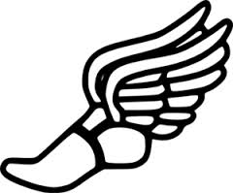
Waterloo High School
Boy’s Track and Field Records

Event | Performance | Name | Year
High Jump | 7'1" | Justin Kretchmer | 2013
Long Jump | 21'2" | Travis Thier | 2017
Triple Jump | 44'7" | Josh Ritzel | 1997
Shot Put | 61'8" | Brendan Duncan | 2013
Discus | 192'7" | Brendan Duncan | 2012
Pole Vault | 14'1" | Mark Yochum | 1985
100 | 11.14CMT | Eric Jost | 2001
200 | 22.94CMT | Eric Jost  David Lutman  Noah Hays | 2001  1982  2017
400 | 49.74 | Noah Hays | 2017
800 | 1:57.09 | Lance Mueller | 2015
1600 | 4:16.67 | Lance Mueller | 2015
3200 | 9:32.48 | Lance Mueller | 2015
110HH | 14.76 | Greysan Moehrs | 2016
300IH | 40.44CMT | Greysan Moehrs | 2016
4x100 Meter Relay | 43.49 | Jon Kreher, Antonio Bean, Travis Thier, Greysan Moehrs | 2016
4x200 Meter Relay | 1:32.40 | Jon Kreher, Antonio Bean, Garrett Simunich, Ian Howard | 2016
4x400 Meter Relay | 3:22.60 | Dawson Holden, Jackson McAlister Sam Rick, Noah Hays | 2017
4x800 Meter Relay | 8:10.96 | Lance Mueller,Cole Rodenberg Jake Schwartz,Blake Rusteberg | 2015

